M2-EmbSys

Module 2- Overview of embedded software, design,development processes and standards

REPORT ON REFRIGERATOR :

Submitted by: Sujata Naikar

PS:99007669

Table of content.

1.Abstract and Introduction.

2.Requirements.

1. High level requirements.
2. Low level requirements.

3.Components.

4.Block diagrams.

1. Primary block diagram.
2. Structural diagram.
3. Flowchart.
4. Sub-system.
5. Sensors.
6. Actuators.

5.Test plan and output.

1. High level test plan.
2. Low level test plan.

6.Application.

1.Abstract and Introduction.

* 1. ABSTRACT.

Refrigerators used in daily life are one of the indispensable tools. Uninterrupted power should be supplied to the refrigerators in order to maintain cooling service. Domestic refrigerator may be operating continuously to maintain proper food storage condition. The continuous operation of this equipment accounts more electrical consumption. A significant amount of waste heat is rejected by the condensers of refrigerator. A domestic refrigerator was modified for the experiments in which the waste heat, generated by the refrigerator, was utilized to maintain the temperature of a warm chamber above atmospheric temperature.

* 1. INTRODUCTION.

Refrigeration is a process of removing heat from one location to another. The work of heat transfer is traditionally driven by mechanical work, but can also be driven by heat, magnetism, electricity, laser, or other

means. Refrigeration has many applications, including, but not limited to: household refrigerators, industrial freezers, cryogenics, and air conditioning .Heat pumps may use the heat output of the refrigeration process, and also may be designed to be reversible, but are otherwise similar to refrigeration units [1]. Refrigeration has had a large impact on industry, lifestyle, agriculture and settlement patterns. Embedding a Microcontroller into any domestic appliance has numerous advantages, both through the development life cycle and production environment. Such one example is a Refrigerator. Establishment of a common hardware and software development platform can be done which can further support a range of appliances for present and potential future needs.

2.Requirements.

There are mainly two types of requirements;

1.High level requirements.

2.Low level requirements.

Though both the types of requirements are more or less depended on each other while functioning, according to the need and usage they are termed as high and low level requirements.

* 1. High level requirements.

|  |  |
| --- | --- |
| Id | High level requirements. |
| HLR1 | The system shall maintain the temperature in the required limit. |
| HLR2 | The system shall have control over alarm conditions. |
| HLR3 | The system shall be able to keep a track on compressor control. |

* 1. Low level requirements.

|  |  |
| --- | --- |
| Id | Low level requirements. |
| LLR1.1  (for HLR1) | From initial power-on, the ambient air temperature of the fridge is typically around +21°C. |
| LLR1.2  (for HLR1) | The user selected temperature is typically set  around +5°C, and may cycle between +8 and +2°C. |
| LLR2.1  (For HLR2) | There are three possible alarm situations. These are, door open, over, or under temperature conditions |
| LLR2.2  (For HLR2) | If the door has inadvertently been opened for a pre-determined time, for example, one minute, an audible alarm will be sounded. |
| LLR2.3  (For HLR2) | The over temperature situation can occur if the fridge door is not closed properly or there is compressor failure or a refrigerant pressure problem. |
| LLR2.4  (For HLR2) | The under temperature case may occur if the compressor is permanently powered-on. In all of these situations the objective is to alert the user. |
| LLR3.1  (For HLR3) | A conventional compressor control case, a more efficient and long-term cost-effective solution can be  implemented using the microcontroller to control the compressor motor using a triac and a relay. |
| LLR3.2  (For HLR3) | The purpose of this relay is to apply power to the compressor motor start and run windings at power-on. |
| LLR3.3  (For HLR3) | And also to maintain power to the motor run  winding after the start-up phase has expired. |

3.Components

The main components are,

1.The compressor.

2.The condensor.

3.The expansion device.

4.The evaporator.

* **Compressor** – It is a hermitically sealed reciprocating pump. It is the heart of the refrigeration system. It pumps refrigerant gas to the different components to effect the refrigeration cycle. Their sizes are from 1/12 horse power to 1 horse power. R-12 refrigerant gas is commonly used. Newer environmentally friendly refrigerant gas such as R-134a is being used for the newer models.
* **Condenser** – It is made of serpentine copper tubes with aluminum fins. The combine heat of gas refrigerant from the evaporator and the heat of the compressed gas refrigerant from the compressor is being dissipated into the atmosphere, and changes the gas refrigerant into liquid refrigerant.
* **Expansion Valve** – copper capillary tube, or "expansion valve", is widely used on refrigeration appliances. Their outside diameter is 2.5mm, and their length is between 8 feet to 12 feet. High pressure liquid refrigerant leaves the capillary tube into low-pressure low-temperature liquid refrigerant.
* **Evaporator** – is a serpentine aluminum tubes with aluminum fins. It absorbs the heat in the freezing and refrigerating compartments and transfers it to the condenser. The low pressure liquid refrigerant turns to gas after absorbing the heat. And is ready to make its journey through the accumulator then to the compressor.

Other components are;

* **Filter/dryer** – It filters the dirt and iron particles from the refrigerant. Some filter Dryer have moisture absorbent materials like, Silica gel or synthetic silicates, which removes moisture from the refrigerant. The filter/dryer protects the compressor by restricting and filtering the impurities and moisture contents in the refrigerant.
* **Accumulator** – is a refrigerant tank. It stores refrigerant so that the evaporator will not run out of it. Without an accumulator, the 2-door no-frost refrigerating unit will exhibit the symptom of refrigerant starvation.
* **Refrigerator-Fan-motor** – The fan motor of a 2-door no-frost is situated at the back of the evaporator coils, and it blows the air into the freezer-coils and distribute the air into the freezing and refrigerating compartments. The room area of the freezer is very much smaller than that of the refrigerator, therefore the temperature can be maintained at a few degrees below 0 Centigrade.
* **Freezer-Fan-Motor** – The fan motor of a freezer is used to cool the compressor. It is situated beside the compressor in the compressor room. It has a stand and steel bracket, and is bolted into a cross-member. The fan runs together with the compressor. Care should be taken not to bend the fan blade during maintenance. The aluminum blade can vibrate furiously and is detrimental to the shaft bearings and can cause early breakdown.

4. Block diagrams.

* 1. PRIMARY BLOCK DIAGRAM OF REFRIGERATOR.

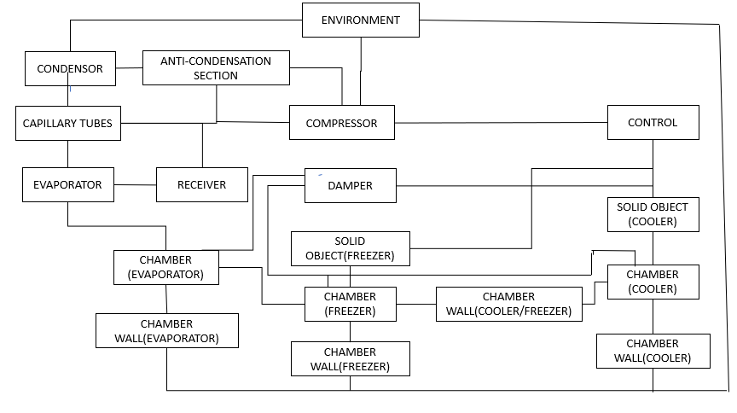

Fig 4.1.1The above figure gives the overall idea about how the system is arranged in the form of block diagram.

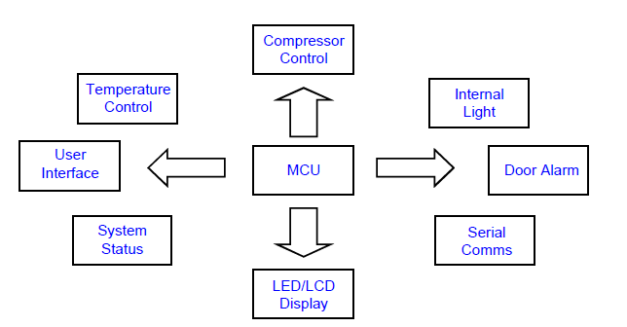

Fig 4.1.2 The main focus in this design is to implement a system solution that will control a domestic fridge compressor based on temperature measurement, with some additional functionality.

* 1. Structural diagrams.

. 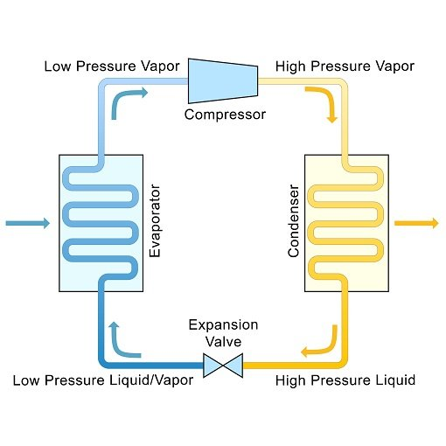

* 1. Flowcharts.

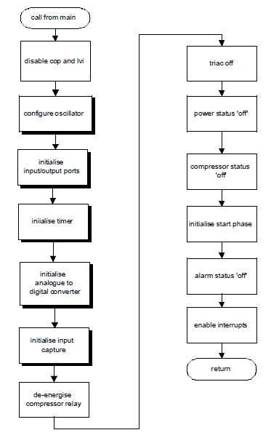

* + 1. Flowchart of the refrigerator function.

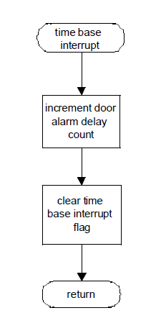

Fig 4.3.2 Time base module interrupt module.

* 1. Sub-systems.

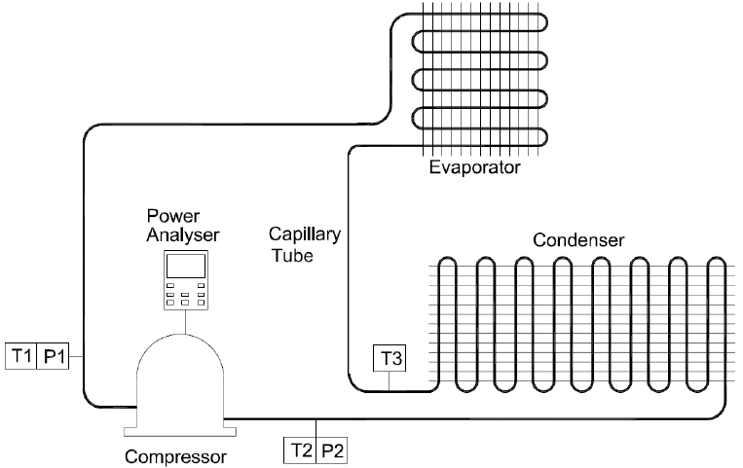

Fig 4.4.1 Schematic diagram of refrigerator.

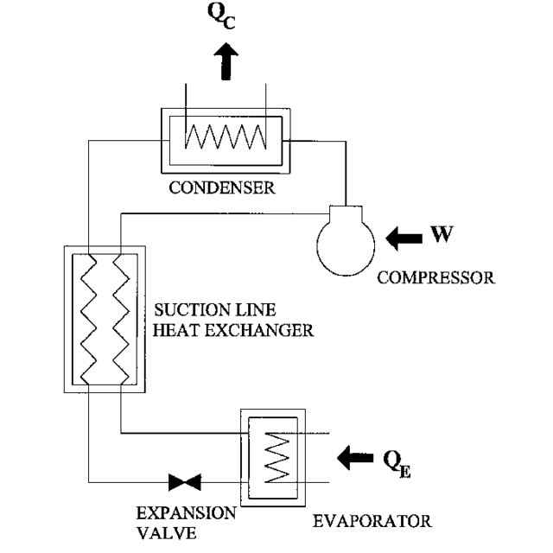

Fig 4.4.2 Freezer system, includes main components of a refrigerator system.

* Explaination to the block diagram.
* Embedded within a domestic Fridge compartment is an Evaporator, and on the outside a Condenser, heat exchanging coils and the refrigerant compressor.
* The compressor is driven by an electrical motor. When power is applied to the compressor the pressure of the refrigerant is increased.
* This increase in pressure causes an increase in refrigerant temperature and the heat produced by this action is dissipated through the heat exchanging coils at the rear of the appliance.
* The refrigerant then condenses and passes through from the high-pressure environment of the condenser through an expansion valve to the low-pressure evaporation system inside the Fridge compartment.
* On evaporating, the refrigerant absorbs heat and subsequently reduces the enclosure temperature.
* The warmer refrigerant is circulated to the outside of the compartment where the cycle repeats under thermal control.
  1. Sensors.

1.Dual Sensor Control with Two Thermo Sensor Controls which enable to increase or decrease the temperature in Freezer & Fridge zone independently.

2. A reed sensor or Hall effect sensor can be used to detect the door's position. For example, in refrigerators, a reed sensor is mounted to the frame of the appliance and a permanent magnet actuator is mounted to the door

* 1. Actuators.

1.Compressor power relay.

The purpose of this relay is to apply power to the compressor motor start and run windings at power-on, and maintain power to the motor run winding after the start-up phase has expired. Additionally, as the relay contact has a low resistance, it does not dissipate power unnecessarily under normal running conditions.

2.A thermostatic actuator **.**

It acts as a valve actuator to open or close a valve based on a temperature setpoint to. i.e The regulating system, consists of thermostatic valve means for controlling the flow of refrigerant to the evaporator having an actuator chamber filled with a refrigerant medium having liquid an vapor phases, and electrical heat supply element in the actuator chamber.

.

Working of refrigerator:

The basic principle is that whenever a liquid coolant is passed through things at a higher temperature, it absorbs the heat; gets evaporated and the cooling effect is produced. The Refrigerator works on the **principle of evaporation**.

i.e, When the temperature of the fridge compartment rises above the pre-selected thermostat setting, the bi-metallic contact closes and line voltage is applied to both the start and run windings simultaneously. The start winding has a lower resistance than the run winding and provide the initial current surge required to start the motor. This inrush of current subsequently raises the temperature of the PTC and increases its resistive property, which in turn reduces the current flow to the start winding. At this point in time, the current through the start winding has been minimised by the PTC, the current through the run winding is stable and the motor continues to run. When the fridge compartment reaches the desired temperature the thermostat contact opens, removing power from the motor. When the compartment air temperature again rises, the temperature control cycle repeats.

5.Test plan and output.

* Testing

The purpose of testing,

1. Increases use-age life of the refrigerators.
2. Save money & save energy as well with using star rating product or CE certified components.
3. Provide faith in product.
4. Improve safety of the product.
5. Improve performance as well.
6. Provide safety to user.

There are various methods of testing,such as;

1.Testing temperatures.

2.Cool-down test.

3. Stable running and power consumption test.

6.Applications:

Applications of Refrigeration in 7 Different Industries

1. District Cooling.
2. Electricity Production.
3. Chemical and Petrochemicals.
4. Pharmaceutical.
5. Food & Beverages.
6. Data Centres.
7. Other industries.